Cloud SIEM tool

Introduction
SIEM Tools
SIEM, or security information and event management, tools function as a part of the wider field of cybersecurity. Their main tasks are to provide real-time analysis of security alerts generated by network hardware and applications. As a result of their importance in enterprise cybersecurity, a wide variety of SIEM tools have become available over the years, each offering different features and capabilities. However, a common problem facing cybersecurity experts and enterprise IT professionals is choosing the right SIEM tool for their needs.
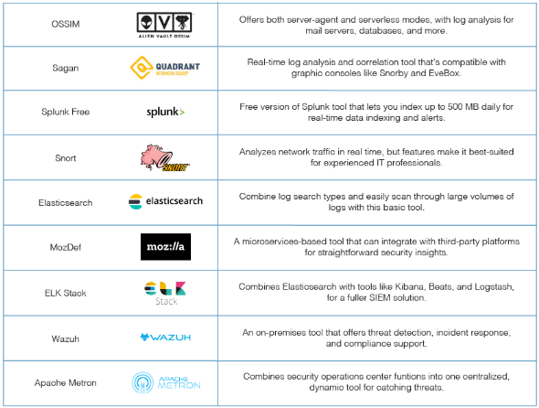

Cloud SIEM tool
SIEM technology is often used in traditional on-premises settings for compliance reporting, log management, and advanced threat management, but SIEM solutions are now moving to the cloud in large numbers as organisations seek light-touch operation for on-premises resources and the cloud-first approach that comes with lower ownership equipment costs and automatically updated software. Some of the cloud native SIEM tools in the market include Azure Sentinel, Google Cloud Platform (GCP) Cloud SIEM and Sumo Logic. But cloud SIEM tools also need, like traditional and SIEMS, agents to push security event logs, telemetry and other detection activities to the cloud for making it analyse the data and find the security event. So, in a way, the significant differentiator is in the opportunity to get information from both on-premises and cloud environments simultaneously, to ensure complete coverage of an organisation’s IT estate in the evolving 'hybrid' generation of cloud SIEM tools.

Cloud features and explanations
Features | Explanation
Attack Timelines | It helps security analysts and other stakeholders visualize the attack timeline across multiple systems and users using a cloud SIEM platform, which groups events by pre-identified / dynamically detected attack patterns.
Cloud managing | Cloud SIEM is well known in managing all types of organization when working with events and security log data securement.
Alerting / Informing | Informing is important part of cloud SIEM features as it aggregates mostly all the data into one specified location, then this data can be used as audits and incidents / investigations, also having an informing gives you the ability to do risk analysis based on the old data saved.
Monitoring | It is possible to aggregate data from physical as well as virtual components located in multiple environments, including multiple clouds and on-premises data centres, using cloud SIEM platforms, which centralize monitoring efforts into a single interface that displays information about integrated systems, workloads, and applications.
Threat Detection and hunting | Cloud SIEMS can identify and prevent future threats using the historical data available, also hunting feature allows the IT security team to run multiple queries and filter the data to check for any vulnerabilities withing the cloud and uncover any threats withing the system.

Advantages and Disadvantages
Advantages | Disadvantages
Cost effective  SIEM cloud services are cost-effective since the SIEM vendor takes care of the infrastructure, and the organization does not have to buy hardware and software. In addition, SIEM services take care of software maintenance and updates and eliminate in-house SIEM overhead. | Future Costs  Using Cloud SIEM can be challenging due to its cost, even though the initial implementation might be relatively cheap to an organization but ongoing costs of using the technology can quickly add up. For example, licensing fees, data storage costs.
Security  Cloud SIEMS can identify and prevent future threats using the historical data available, also hunting feature allows the IT security team to run multiple queries and filter the data to check for any vulnerabilities withing the cloud and uncover any threats withing the system. | Unavailable internet connection  As Much as cloud is very smart way to save and maintain the data it is also inaccessible when you don’t have a connection to the internet, As the cloud SIEM is fully dependent on internet connection for real time updates and monitoring, it can impact any security incidents response.
Regularly updated and maintained  Usually Cloud SIEM are automatically updated and maintained from their organization selected providers, AS the providers update and maintain their platforms regularly including minor patches and hardware maintenance. | Data management  There are several limitations to using Cloud SIEM, including the need to manage and store large volumes of data. As the system collects and analyses security logs, it can generate a large amount of data that must be managed and stored appropriately. When an organization lacks storage capacity or data management expertise, this can be a challenge.

Costs and plans
Pricing Plans type | The plan
Basic / standard plan | The Basic Plan is used the most, it has less features than the premium but include the essentials features and has simple security attention.
Enterprise / advanced plan | Enterprise plans usually sell the whole set of products and features that the cloud SIEM tool is offering (Comprehensive), this is usually targeted at big organisations.
PAYG plan | Pay as you go plans are most common between small business and individuals, another pay as you go feature for organisation is they only pay for the products and resources used.
Free / Free trial Plans | The free plan is usually limited and has minimal features and sometimes cloud services offer free trial to offer the customer their customer they can get if they pay for the full service.
Recommendation
Many cloud SIEMS are powerful and good and offer a great threat detection and advanced features, it’s also easy to use and has a great scalability and integration with most SIEM clouds, Most used SIEM clouds are Microsoft sentinel, Splunk Cloud, Sumo Logic, Google Cloud Security Command Centre (SCC), LogRhythm Cloud and many more in the market.

